Problem Defination and Features

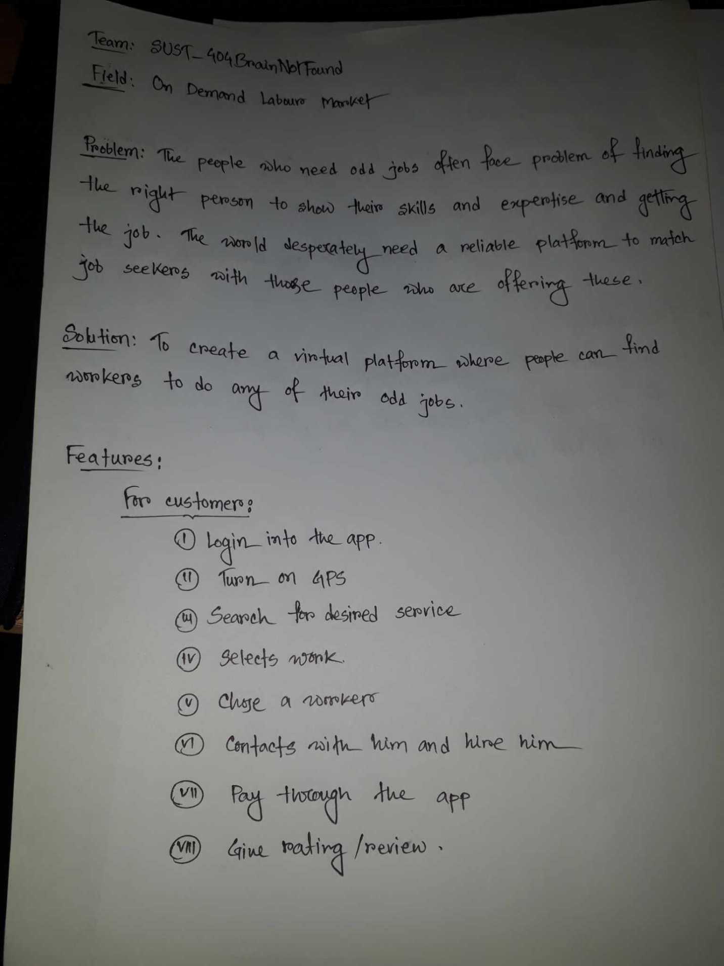

Figure : Problem defination and features

StakeHolder

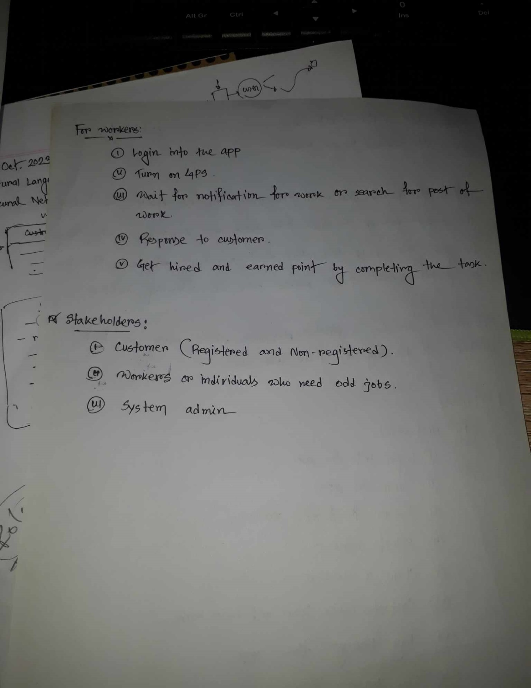

Figure : StakeHolders

UseCase Diagram

Figure : UseCase Diagram

Entity Relationship Diagram



Figure : ER Diagram